Sit me up  
Lay me down  
Toilet  
Hungry  
Cold  
Hot  
Frightened  
More painkillers  
Need quiet  
Need radio  
Sleeping tablet  
Water

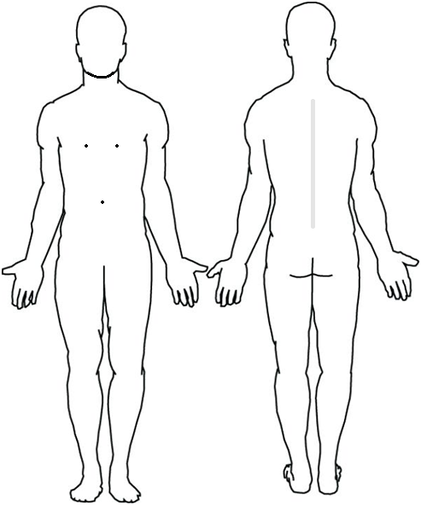

Pain here Itch here

Comforting hands here (where to place hands - for friends relatives)  
Massage here (very gently)  
Tea Coffee +1 sugar Soup

Sit me up  
Lay me down  
Toilet  
Hungry  
Cold  
Hot  
Frightened  
More painkillers  
Need quiet  
Need radio  
Sleeping tablet  
Water



Pain here Itch here

Comforting hands here (where to place hands - for friends relatives)  
Massage here (very gently)  
Tea Coffee +1 sugar Soup